**Project Design Phase-II**

**Technology Stack (Architecture & Stack)**

|  |  |
| --- | --- |
| Date | 03 October 2022 |
| Team ID | PNT2022TMID16219 |
| Project Name | Project – A Gesture-based Tool for Sterile Browsing of Radiology |

**Technical Architecture:**

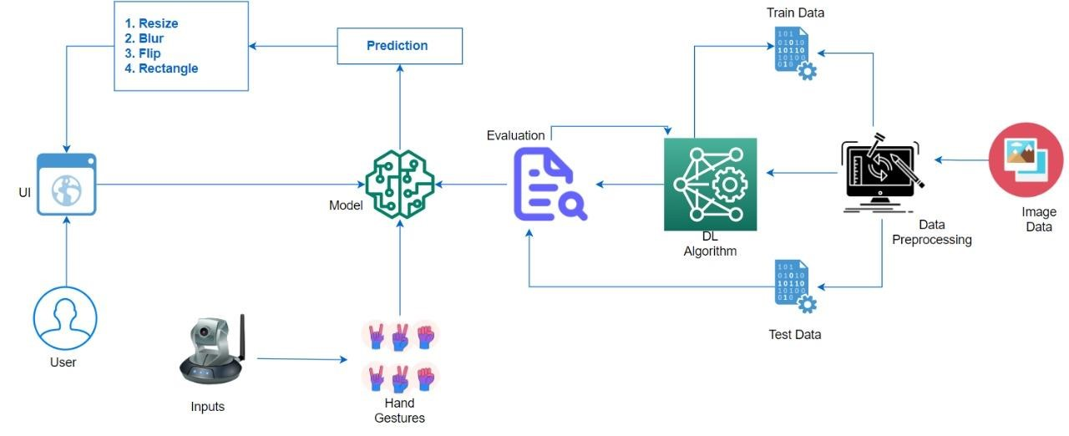

**Table-1 : Components & Technologies:**

|  |  |  |  |
| --- | --- | --- | --- |
| **S.No** | **Component** | **Description** | **Technology** |
| 1. | User Interface | Web UI | HTML, CSS, JavaScript. |
| 2. | Application Logic-1 Image Pre-processing | Input image is pre-processed with the help of library files | Python, TensorFlow |
| 3. | Application Logic-2 Building Model | Building CNN model to recognize the gesture. | Python, Keras |
| 4. | Application Logic-3 Creation of app | App is built to obtain gesture as input and to provide as output. | HTML, CSS, JavaScript |
| 5. | Dataset | Hand gesture data set. | From IBM |
| 6. | Cloud Database | User input image is stored in cloud. | IBM Cloud |
| 7. | File Storage | File storage contains dataset and source code. | Server and Local Filesystem |
| 8. | Machine Learning Model | CNN Model was used to recognize the preprocessed image by image capturing or by video segmenting. | CNN Model by Python, Keras |

**Table-2: Application Characteristics:**

|  |  |  |  |
| --- | --- | --- | --- |
| **S.No** | **Characteristics** | **Description** | **Technology** |
| 1. | Open-Source Frameworks | For development of code, package manager, for building model | Visual Studio Code, Conda, TensorFlow |
| 2. | Resilient | Gestures can be captured in different environments (variable brightness and distance). | OpenCV, TensorFlow |
| 3. | Availability | Deploy on highly available server | IBM Cloud |
| 4. | Performance | CNN model is used to predict the input gesture in a shorter span of time. | TensorFlow, Keras |
| 5. | Diverse Dataset | Data augmentation to generate more data from limited set of images. | Keras |